St. John the Baptist Parish
4050 Durham Rd. Ottsville, Pa. 18942
Beef and Beer
Designer Bag +
Power Tool Bingo
Saturday June 8th
doors open 5:30pm games start 6:30pm
Designer purses + power tools
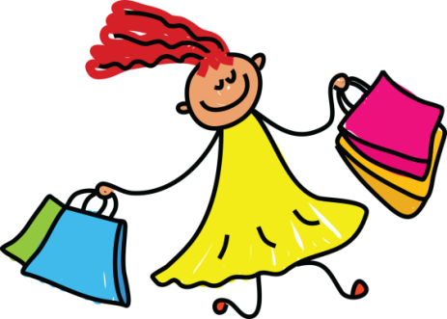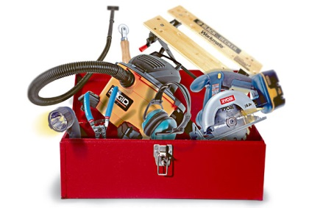
*Invite your family and friends for a fun filled night*
*Tickets can be bought through parish or school office
or call 215-534-1970
*$35 in advance or $40 at the door
(ticket includes 18 games, one beef sandwich and one beverage
does not include frozen drinks)
2 special games sold separately
Checks payable to St. John the Baptist Parish
*Additional food, beer, wine available for purchase
(no outside food or beverage)
*Great Door prizes, awesome raffle baskets, 50/50
the Bingo you don’t want to miss!

